OVERLEAF & LATEX INSTRUCTIONS

CS330 - 001 • WINTER SEMESTER 2019

**INSTRUCTOR: ANDRÉ DOS SANTOS**

**dossantos@cs.uregina.ca • andreeds.github.io**

horizontal line

## Overleaf



Overleaf primary product is an online, real time collaborative editor for papers, theses, technical reports and other documents written in the LaTeX markup language.

For more info: [**https://www.overleaf.com**](https://www.overleaf.com)

For personal use (only one collaborator), Overleaf is free. Register [**here**](https://www.overleaf.com/register).

## Latex Template

After registering to Overleaf, your have two options to obtain the template.

### 1. Use the template link on Overleaf

a. The template is available [**here**](https://www.overleaf.com/latex/templates/cs330-assignment-template/wjtyxcpwpfmw) ([**https://tinyurl.com/yj6nlvgp**](https://tinyurl.com/yj6nlvgp)).

b. Click on "Open as Template"



c. Modify it accordingly.

### 2. Download the template from URCourses

a. Download the Latex file named **cs330_assignment_template.zip**

b. On Overleaf click on "New Project"



c. "Upload Project"

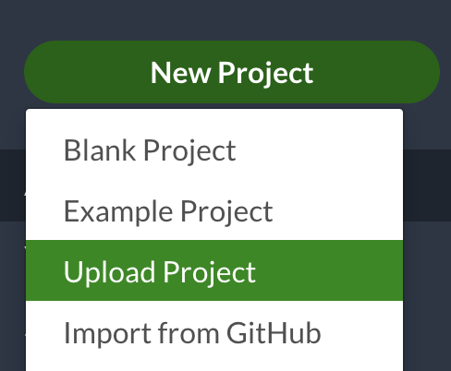

d. "Select a .zip file”



e. Select **cs330_assignment_template.zip** from your computer.

f. Modify it accordingly.

## 

# LaTex

LaTeX is a high-quality typesetting system; it includes features designed for the production of technical and scientific documentation. LaTeX is the de facto standard for the communication and publication of scientific documents. LaTeX is available as free software.

For more info: [**https://www.latex-project.org/**](https://www.latex-project.org/)

All Latex instructions are in the template file provided.

## LaTeX cheat sheet

Posted on URCourses is a cheat-sheet with all the symbols you should need. There are some general advice about writing mathematics in LATEX and a few examples.

## Obtaining the PDF file

Once you are done with the changes, it is time to submit the PDF as your assignment. To download the PDF file from Overleaf:

a. Click on "Recompile" one last time to guarantee you have the latest version of your source code on the PDF.



b. Click on "Download PDF".



c. Upload it on URCourses.

## 

## Inserting Figures/Graphs

Although there exist some libraries to draw graphs directly in LaTex, they are often complicated and time-consuming.

1. Draw the figure in Softwares such as **OmniGraffle**, or online in [**draw.io**](https://www.draw.io/)or **Google Drawings.**
2. Download the figure containing the graph in a document type such as **.png** or **.jpg**. Remember the name and extension of the figure, you will need later.
3. [**Upload the figure to Overleaf**](https://www.overleaf.com/learn/latex/Inserting_Images)
4. Add the following to your LaTex code where applicable:

*1* \begin{figure}[h]

*2* \centering

*3* \includegraphics[width=0.5\textwidth]{figure_name}

*4* \caption{Describe the figure here.}

*5* \label{this_is_the_label_to_ref_the_image}

*6* \end{figure}

Line 1: [h] is to indicate the compiler to print the figure here

Line 2: Aligns the figure in the center of the page. Removed it to align it to the left

Line 3: 0.5 means the figure will have its width equal to 50% of the page width.

Line 4: figure_name That is the name you saved the figure in Step 2. The figure must be in the same directory as the main.tex is. If the figure is in a folder, add the name of the folder, e.i., directory_name/figure_name